Minor’s Policy Communication Plan for Girl’s STEM Camp (Middle School Students)
The Center for the Ultra-wide-area Resilient Electrical Energy Transmission Networks (CURENT) is dedicated to providing a safe environment for your child. We believe that we have done an excellent job in the past but due to increased state and national attention to security, we have formalized our policies to provide awareness to parents. Our facilities are inherently not equivalent to a middle school so additional adult supervision has been implemented to provide a similar level of security. To provide this environment we have established the following policies:
- The drop-off/pick-up point will be the 4th floor Min Kao entrance. Instructions to this location can be found later in this document. A sign-in/sign-out sheet will be located inside these doors and parents must sign-in/sign-out their student.
- Students can be dropped off up to 20 minutes before the start of the program. The drop off time period is between 8:40 am and 9:00 am. .
- If a student needs to be dropped-off after this time period, they can be brought to the classroom for sign-in (either Min Kao Room 416 or Min Kao Room 419)
- If a student needs to be picked-up before the end of the day, then Judy Evans needs to be contacted in advance of pick-up.
  - People picking-up students need to be on an authorized pick-up list and must show photo identification at the time of pick-up.
  - People not on the list asking to pick-up students will not be allowed to leave with the student until we have confirmed the situation with one of the parent contacts.
- Electronic devices will be asked to not be brought to the camp; otherwise, devices will be collected at the beginning of the class.
- During normal operation of our program your child will be primarily located in Min Kao Room 416 (project room), Min Kao Room 419 (lecture room) and Min Kao Room 418 (Tesla computer lab).
- Contact information for the main representatives of the camp are located below for you benefit.
- All contacts and teachers of the camp will have undergone Minor Participation training and background checks prior to the start of the program and be approved by the Education Coordinator.
- Campers must be in pairs and with approved adult when outside the common classrooms.
- Campers will be escorted to and from the restrooms by an approved adult.
- The restroom will be checked prior to the girls using the facilities and the adult will wait outside the restroom.
- A field trip is scheduled for Thursday, June 30th. A permission form detailing times, locations, and contacts will be provided and bottom portion of the form must be returned and signed.
- Field trip campers will be transported by 12 person van or university-procured buses. A ratio of 5 campers per adult will be maintained to watch over the campers. All adults will have been approved by the Education Coordinator. Campers must:
  - Follow the directions of their chaperoning adult
  - Stay with the chaperoning adult
  - Remain in the groups with their peers
  - Comply with all University and Facility rules
- Students that do not obey rules or cause other problems may result in conferences with the Education Coordinator, parent conferences, elimination of field trip eligibility, suspension, or termination from the program.

CURENT Contacts
Name | Office Phone # | Cell Phone/Text # | Email
Dr. Chien-fei Chen | 865-974-3787 | 509-432-5075 | cchen26@utk.edu
Mr. Erin Wills | 865-974-9401 | 423-612-0611 | ewills1@utk.edu
Ms. Wendy Smith | 865-974-9707 |  | wksmith@utk.edu
Ms. Judy Evans | 865-974-9712 |  | jevans20@utk.edu
Ms. Pam Arrowood | 865-974-9134 |  | parrowoo@utk.edu

Classroom Location:
MHK416 – Tesla Computer Lab
MHK418 – Project Room (also known as Programming Clinic)
MHK419 – Lecture Room

Driving Directions:
Primary Drop-off – 4th Floor Entrance of Min Kao Building
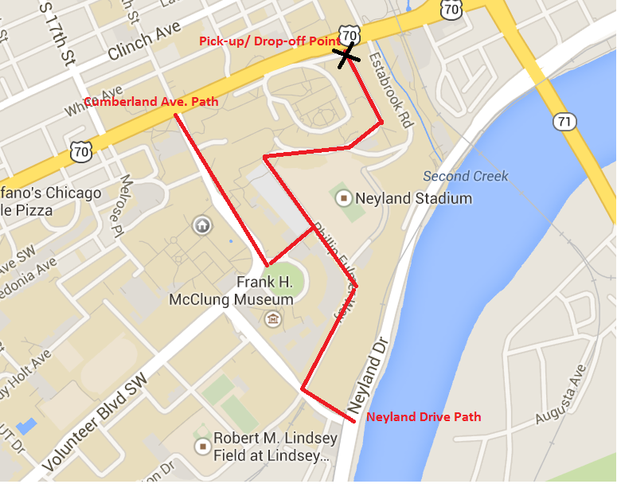
A secondary Drop-off has been developed in case the primary drop-off has obstacles or is too difficult to navigate. Please try to accommodate our request of using the primary location since it is the most controlled drop-off point. The secondary drop off will be in Lot 7 which is about half a block from the building. If the first day proves to be problematic then we will provide instructions at the check-in table for the alternative directions.

CURENT Contact Form
Please include at least three contacts that are available for calls during camp hours (8:40 am – 4:20 pm). Preferably cell phone numbers are also included. Please list contacts in order that we should call with most important (primary contact/ guardian) being first in the table. Additional information can be attached to this form on a separate page.
Name | Relationship to Camper | Office/Home Number | Cell Phone Number | Email Address
Primary Contact/Guardian:

Please provide all people that you wish to have permission to pick-up your child (Note: photo ID is required for pick-up)
Name | Relationship to Camper
Modifications to this form can be made only by Guardians of the camper.
Are there any food restrictions, food allergies, medical issues, or other information that may be important during this camp that we should be knowledgeable about?
__________________________________________________________________________________________________
__________________________________________________________________________________________________
__________________________________________________________________________________________________
__________________________________________________________________________________________________
I understand and will comply with the rules established by CURENT:
Signature of Primary Contact _________________________________________ Date ___________________
Printed Name __________________________________________

