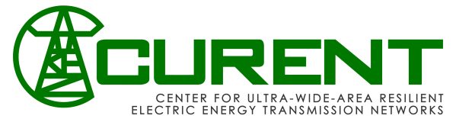
Assumption of Risk and Release of Liability
I, ___________________________________, in consideration of the opportunity for my daughter to participate in the Adventures in STEM Camp at the CURENT Engineering Research Center, and the University of Tennessee, Knoxville, acknowledge the risk of accident or injury inherent in participation in the activities involved in the camp and all related activities. I agree that the University of Tennessee will not be responsible for any personal injury, including death, to me or damage to my property, unless negligently caused by employees of the University of Tennessee. I acknowledge that any claims for personal injury, death or property damage resulting from the negligence of the University of Tennessee employees shall be submitted to the Claims Commission for the State of Tennessee in accordance with the T.C.A. Section 9-8-307, et seq., as amended. I assume liability for and agree to indemnify and to hold the University and its employees harmless for all claims or damages caused, in whole or in part, by me and any negligent, intentional, or other act or omission on my part.
I agree to abide by all regulations, policies, and procedures of the University of Tennessee while in or on the premises where any camp activity is being conducted, following all instructions and procedures in order to maintain a maximum level of safety. Furthermore, I give the University of Tennessee permission to transport me by bus or van to an off-campus site or facility, if needed. I acknowledge that participation in the camp program is wholly voluntary. I understand that there is no medical insurance policy carried by the University of Tennessee and that I should make sure that I am covered in the event of a serious accident.
I also give permission for any emergency medical care or treatment by a physician, surgeon, hospital, or medical care facility that may be required, and accept responsibility for the costs.
I am above the age of 18, or my parent or guardian is above the age of 18, and have read the above statement and agree to the conditions set forth herein. This release and hold harmless agreement binds the members of my family and spouse, and my estate, heirs, administrators, personal representatives, assigns, and any other person entitled to act on my behalf. This agreement shall be construed under the laws of the state of Tennessee without regard to its conflict of law provisions and jurisdiction and venue will be in Knox County, Tennessee. If any portion of this is held to be invalid, illegal, or unenforceable, the remaining portion shall be in full force and effect.
I, or my parent or guardian, have read this document before signing it and sign this document of my own free act and deed, intending to be bound by the promises I have made herein.

_________________________________________
Student Name (Please Print)

______________________________________________________________________
Guardian Name (Please Print) Signature Date

